**Week I**

**Hao Huang 20204205**

1. ***What are levels of words? Which is preferred in academic writing?***

* *They are formal words, common words and informal words. The formal and common words is preferred in academic writing, while informal words isn’t a good choice.*

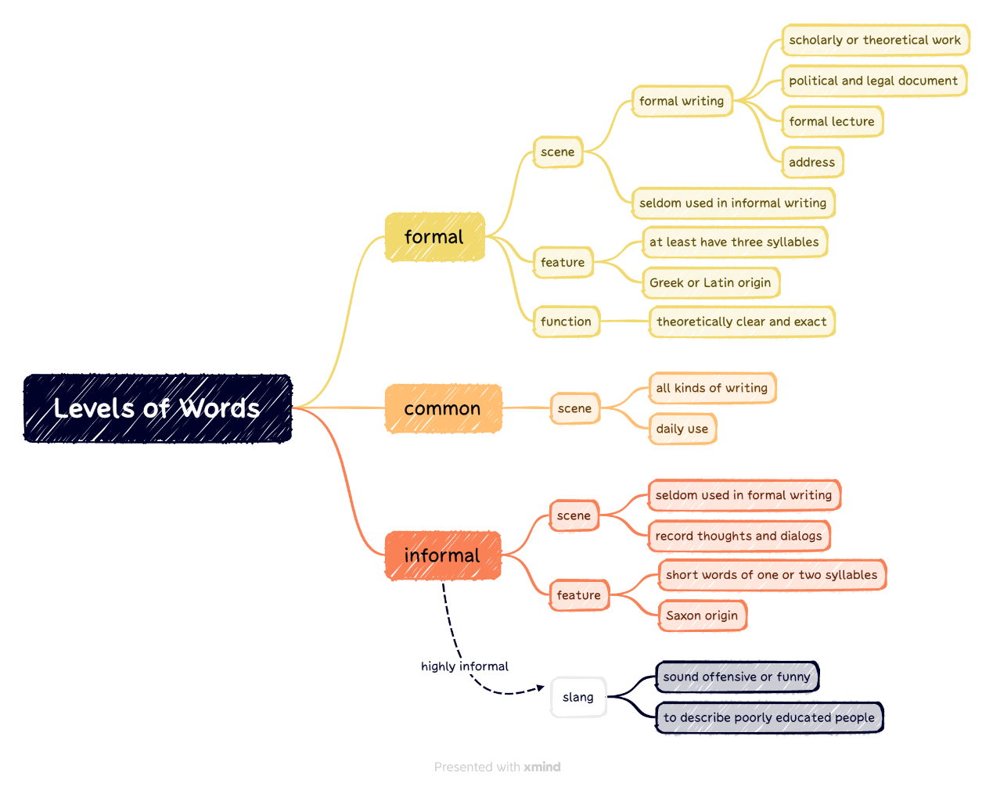

1. ***What are the types of sentences, their meanings and how to use?***

* *See the mind map below.*

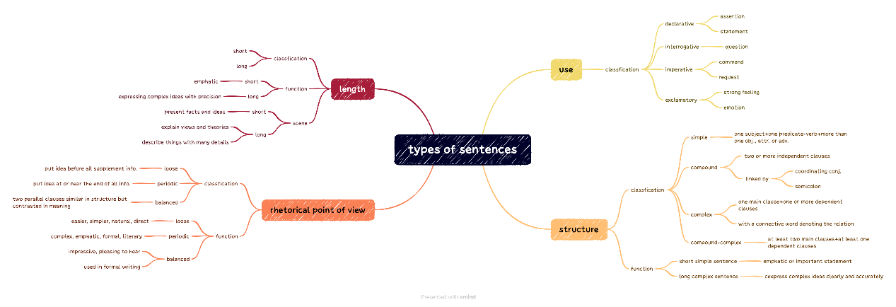

1. ***What are the criteria of an effective paragraph, their meanings and how to use?***

* *Unity, coherence and transition. Unity means focusing the topic. Coherence is concerned with its form or organization. Transition means smoothness of sentences running to another. The unity often need a central theme, it can be concluded with a topic sentence or be implied. Coherence often need writer to figure out a logic order to present the content. The usage of transition can be seen in the mind map below.*

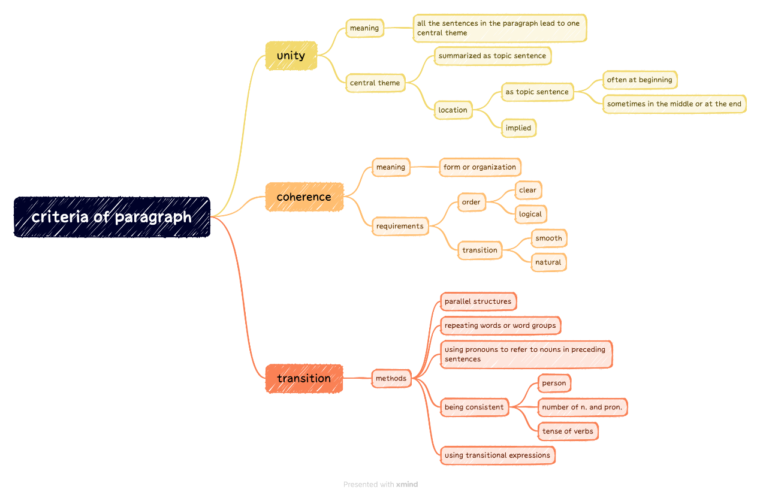

1. ***What are the steps in writing a paragraph? Can you figure out the structure of a paragraph?***

* *Step 1 is to Think of a topic or theme or main idea and express it in a complete sentence. Step 2 is to think of the details or examples or facts that support the main idea. Step 3 is to work out an outline to arrange the details or examples or facts in logic order.*
* *The structure of a paragraph is topic sentence followed by details or examples or facts which support the main idea. They should be well-arranged by suitable outline.*

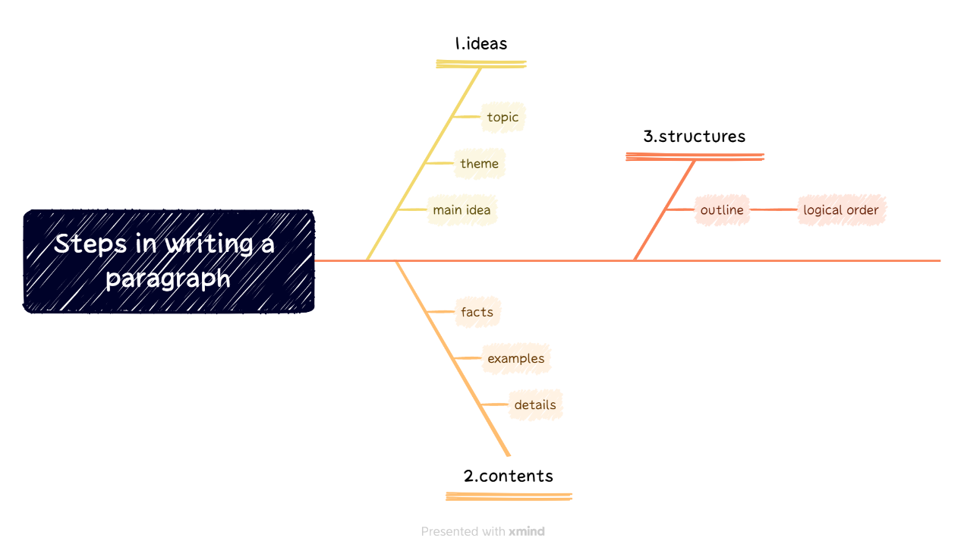

***How to use in future study or work?****It’s obvious that the homework focuses on the way to organize our academic writing. So what I’d learnt can be applied to academic writing. To be detailed, I’d like to summarize with these key points below:*

* *For words, pay attention to its usage and application scene. Avoid informal words being used in academic writing.*
* *For a sentence, pay attention to the usage of different forms of sentences.*
* *For a paragraph, unity, coherence and transition make sense.*
* *Before writing a paragraph, pay attention to outline, themes and materials.*

*Well, these are conclusions toward the academic writing. Excluding the academic writing, we can learn some methods to other works. For example, when giving presentation, we should also pay attention to the topic, coherence and transition. When having conversation with each other, pay attention to usage of words also counts. etc.*